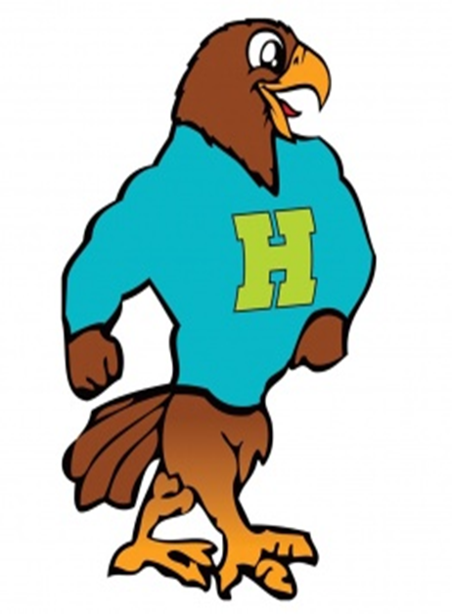

**Herbert Akins Road Elementary**

**[ECS2] Supply List 2024 - 2025**

|  |  |  |
| --- | --- | --- |
| Item | Amount Needed | Notes |
| * Giant Elmer's glue sticks | 6ct |  |
| Crayola Jumbo Crayons | 16ct |  |
| * Large pack of velcro dots | 1 pk |  |
| Paper towels | 6ct |  |
| Ticonderoga Pencils | 12pk |  |
| * Black 1 inch binder with clear sleeve on front | 2 ct |  |
| Black composition notebook | 1ct | Wide ruled |
| White copy paper | 1pk |  |
| Color copy paper | 1pk |  |
| Scotch thermal laminating sheets | 1 pk 200 ct |  |
| Glue dots | 1 pk |  |
| Cardstock any color |  | Any would be appreciated |
| Pencil box ( any color) | 1ct |  |
| Clorox wipes | 3ct |  |

**\*\*Individual teachers may request additional supplies to support learning in their classroom. Please check in with your teacher at our Meet the Teacher event in July. Feel free to bring supplies to the Meet the Teacher event.**